**CONFERENCE SELECTION**

The delegate app aims to give people attending conferences a simple, user-friendly and robust way of working out their schedule and arranging meetings – regardless of the Wi-Fi or online availability.

Users first select a conference from a list of conferences they’ve already logged into on the landing page of the application. Or they can choose to add a new conference. The main purpose for this to allow multi-user login’s as well as multi conference login.

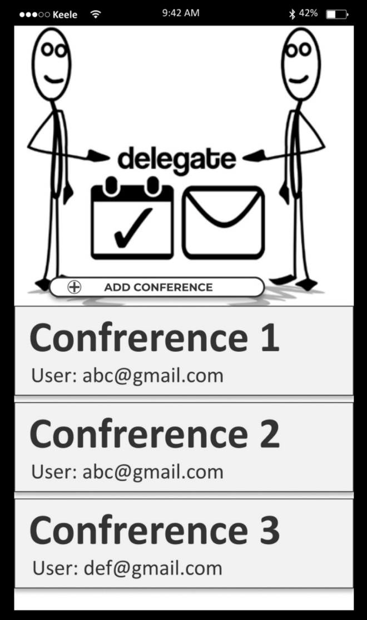

This will be the only button available when application is run for the first time.

When a user needs to login to a new conference, they will click here which will take them to the login page where they enter details supplied via an email.

An added “logged in” conference button will appear here. When the user clicks on here, It takes them directly to their selected conference page (after a set time, the user will be forced logged out & will see the login page again).

**CONFERENCE LOGIN PAGE**

A user has to supply an email address as well as an event ID and attendee ID – supplied by the conference when an individual books their place via an email sent to them.

This page also prompts users to read the terms and conditions of the General Data Protection Regulations. Keeping a clean interface is a key point to note throughout the application so that any user base will be able to navigate quickly and confidently.

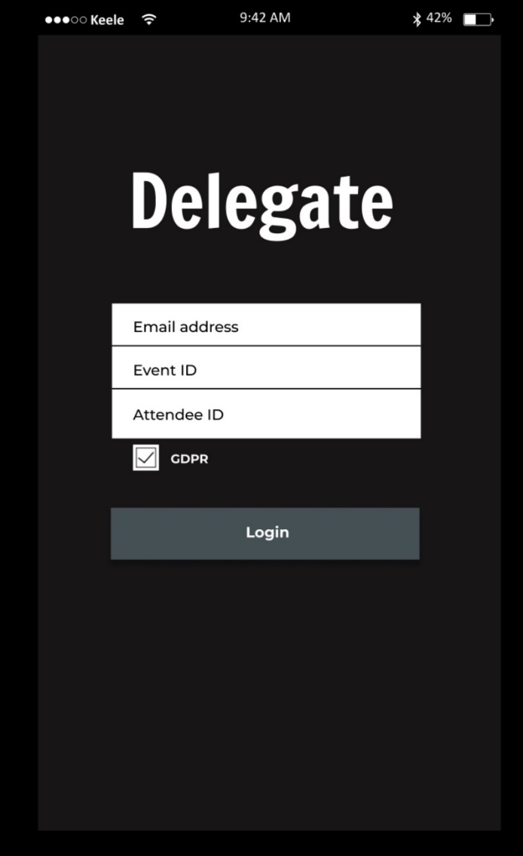

Details from an email will be used to login to the users account. Acceptance for GDPR will be required (details from a link are provided). If correct details have been entered, the user will be taken to the home screen.

**HOME PAGE**

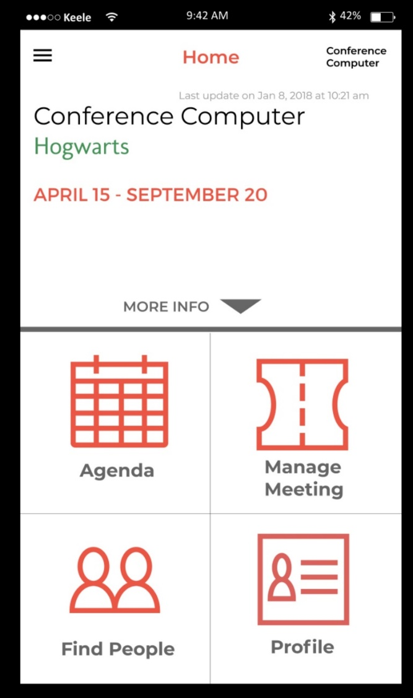**CONFERENCE INFORMATION DROP DOWN**

UPDATES POST MEETING:

* Last update now says = “Latest sync x ago”
* Manage Meeting changed to “Meeting Request”
* Profile changed to “Create Meeting” – links to find people page
* Profile now found in burger button side bar only
* Exit logo added underneath burger button (back to conference home page)

Tapping on this “burger” button, side navigation bar will pull out across the screen

Clicking on the more info section will pull out all information for the event including: name, date, time, location & a blurb of the conference.

Tapping on the Profile icon will take the user onto their personal Profile page.

Tapping on the Manage Meeting icon will take the user onto the Manage Meeting page.

Tapping on the agenda icon will take the user onto the Agenda page.

Tapping on the Find People icon will take the user onto the Find People page.

Once logged in, users will see a page providing details of the conference they have selected (location, description, map’s link etc.) as well as navigation to find out about the sessions they have signed up to, search for friends and colleagues at the conference, a simple way of arranging meetings. They can also customize the profile that other users will see.

The application also recognises that users are likely to have limited signal or Wi-Fi connections and provides consistent feedback on when data was last synced and helps to continue providing functionality during this periods.

The conference details are supplied by the organisation and provides details of times, and location. A user can click to see the location of the event in a mapping application such as Google Maps. Having an all in one location for all conference details means that the user does not have to navigate through the application to obtain details such as these which would be important early and key quick referencing material during the conference.

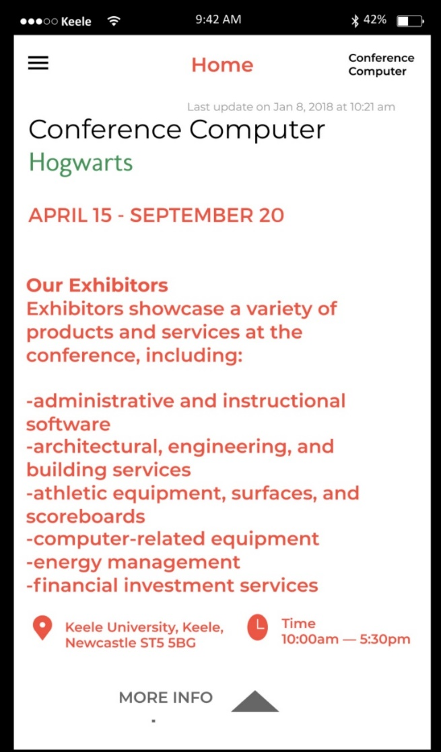

This will have hyperlink to the location of the conference using the google maps app.

Clicking on this tab will hide the conference information, showing the homepage icons again.

**SIDE PANEL NAVIGATION**

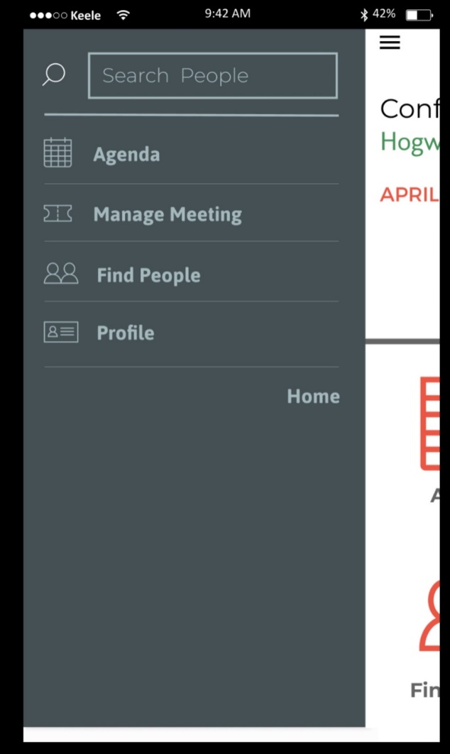

This will take the user back to the conference page where they can go into a new conference (not logged out just changing conferences)

Takes the user to their Profile page (same function as the homepage icon)

Takes the user to the Find People page (same function as the homepage icon)

Takes the user to the Manage Meeting page (same function as the homepage icon)

Takes the user to the Agenda page (same function as the homepage icon)

Tapping the burger button or the available screen space will take the user back onto the page currently being viewed.

There is a persistent side menu which pops out to show a text based version of the homepage buttons. This allows users to move from section to section without the need to refer back to the homepage each time.

UPDATES POST MEETING:

* Button added for “conference home”
* Amended list to match updated names from options page (“conference information”)

**AGENDA**

The Agenda button takes the user to a page which contains all confirmed meetings. An initial list will contain simple information about Event & meeting name, location and the time/ date.

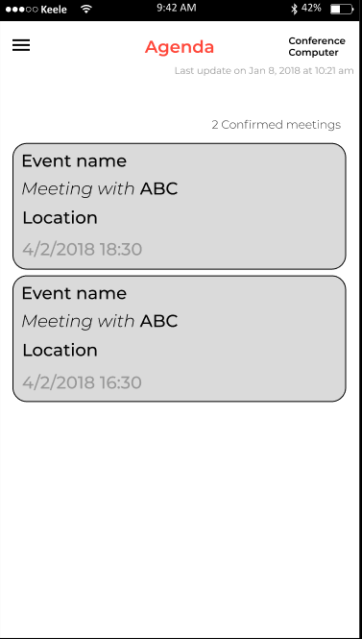

Containing confirmed “**Seminar**” information, when clicked, takes you to a page containing all seminar information: time, date, location & potentially information on the seminar

Containing confirmed “**meeting**” information, when clicked, takes you to the confirmed meeting page.

UPDATES POST MEETING:

* Back button added
* Added a “more” word inside each box for clarity

**AGENDA CONFIRMED PROFILE SECTION**

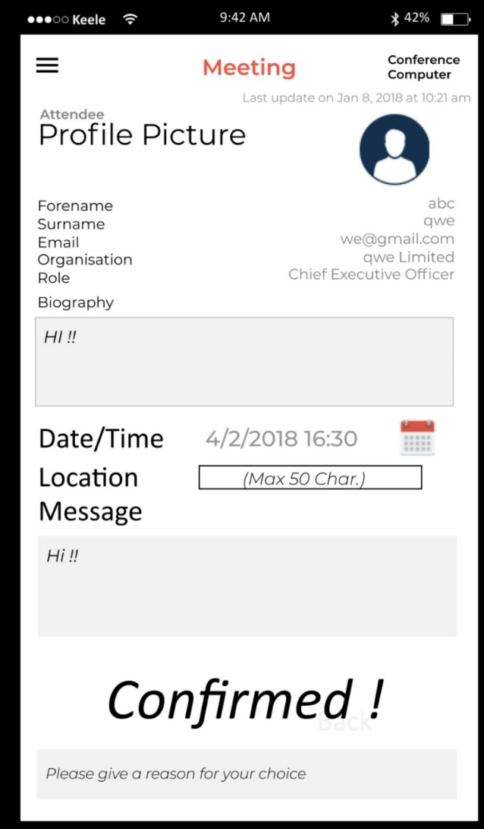

UPDATES POST MEETING:

* Back button added
* Removal of headers for each line (just shows username, not name = username)
* Reduction of whitespace on page

NEED FOR A CANCEL/REJECT BUTTON POST CONFIRMED?

When the user clicks on any of the agenda meetings, they will be forwarded onto the following section which contains all details for the selected meet. This is particularly useful for when a user wants to recap on the fellow attendees profile details and biography & if a message has been included relating to the meeting.

**MANAGE MEETING**

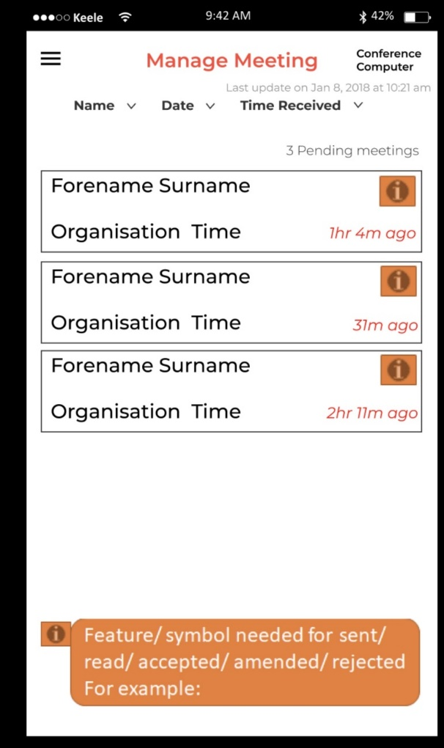

UPDATES POST MEETING:

* Back button added
* Outgoing, Ingoing symbols to indicate message direction
* Tick, cross, question mark for the current action state of the meeting request
* Button added to “Create New Meeting” – links to find people

User has the option to filter/ sort the meetings list if required by: Name, date or time (default set is too time received).

Box contains basic information on request (Pending, accepted, rejected + if it has been sent successfully).

Tapping on this takes the user to the Individual meeting w/ profile page.

The Manage Meeting section is the first stop for the users to go when viewing all sent & received meeting requests.

Similar to the search people page, it will contain a list of all sent & received requests. Symbols next to each request will represent if it is accepted/ amended or rejected as well as a time stamp for the time is was successfully sent or received.

Potential use as well for a filter bar at the top in case there is a multitude of requests for the user to deal with.

**INDIVIDUAL MANAGE MEETING BREAKDOWN**

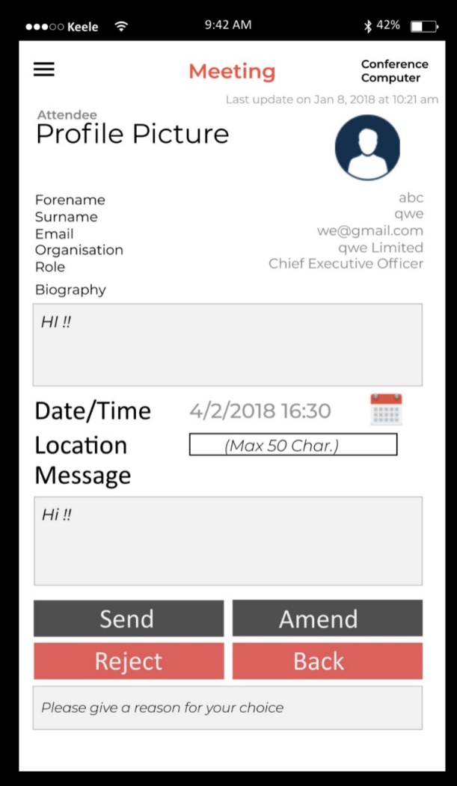

UPDATES POST MEETING:

* Back button added
* Same clarity of each line as agenda profile section
* Word changes – Reject = “Decline”, Amend = Response”

If the meeting is a request from another user: it will show as accept. If accepted, it is moved to “confirmed” and also moved into the Agenda.

If meeting is a new meeting request by the user: it will show as send. If send is pressed, the request is sent to the requested user and then put into Manage Meetings as a “pending” meeting.

Either way, user is then taken back to the Manage Meetings section.

Tapping this button will reject the meeting request. This will notify both users of the rejection within Manage Meetings. User can chose to give a reason for declining the meeting if they so wish. Shows as declined in Manage Meetings and then takes user back to said page.

Clicking on the Amend button will clear the above Date, location & message and allow the user to input the new request. Sends off the request to the other user and creates a “pending” request in the personal users manage meetings. Then taken back to manage meetings.

Click this button to simply go back to the manage meetings section without any changes made.

A user who clicks the meeting button will see a page where the individual’s details are listed along with a form to arrange the date, time, location and a short message. This further allows the user to be able to keep referring to the profile section while they write up the message.

**FIND PEOPLE**

The ‘find people’ function provides users with a way of finding attendees. The autocomplete search, based on the latest update, returns results based on organisation or conference attendee. A simple & clean listing of all attendees based on search filters & user input means that the individual user is not cluttered with too many options.

When a user has found their desired search, clicking anywhere within the box moves them onto the attendee’s profile page.

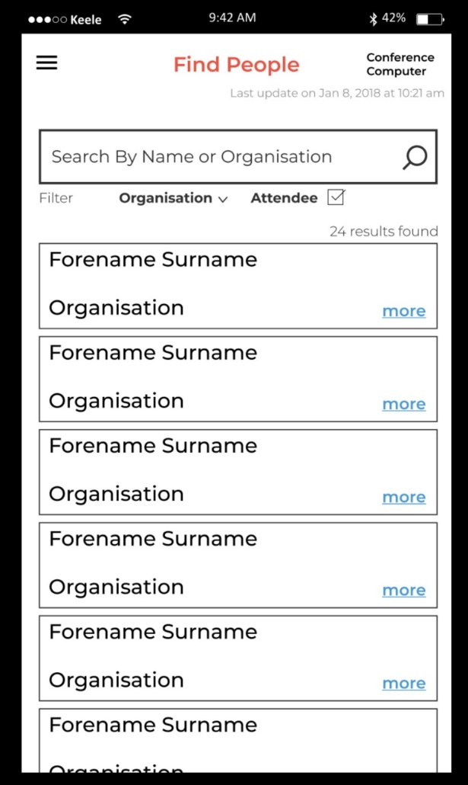

Box contains basic information: Name, Organisation.

Clicking on this area will take the user to the requested user’s profile.

User can type either a name or organisation in here and the data below will begin to filter according to this.

**ATTENDEE SEARCH PROFILE PAGE**

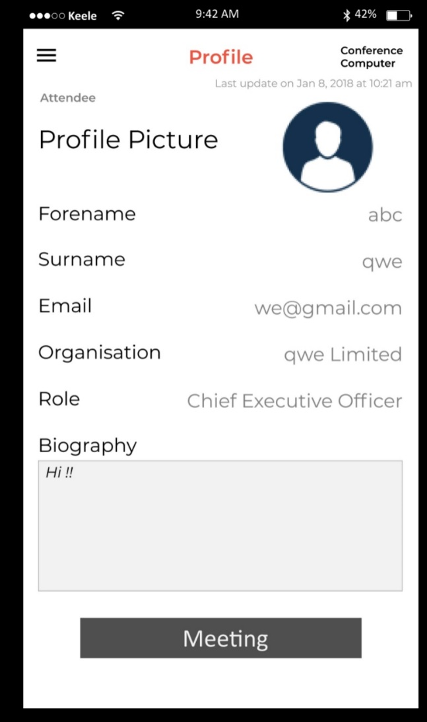

User can click on this “meeting” button which will create a drop down to arrange a meeting with the requested profile.

A similar page is presented to users when a result in the ‘find people’ page is selected, with a prominent ‘meeting’ button.

Having the meeting organiser within the page from the search means the app has a consistent flow as well as allowing the user to double check the details of the attendee in question before then firing off a meeting request.

UPDATES POST MEETING:

* Back button added
* Same clarity changes as agenda profile page

**ARRANGE MEETING – PROFILE SEARCH SECTION**

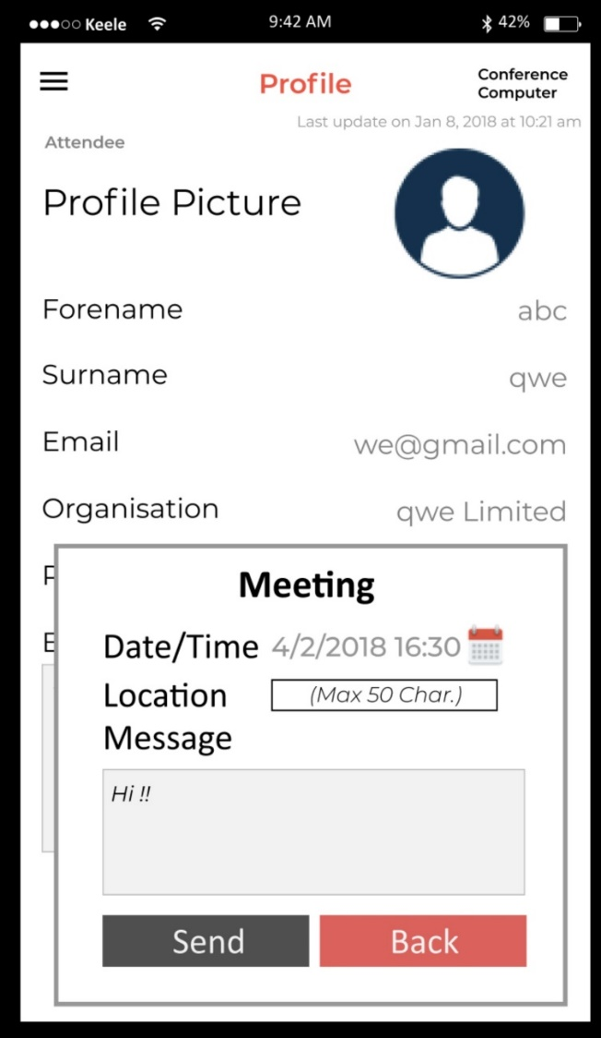

UPDATES POST MEETING:

* Back button added
* Same clarity changes as the agenda profile page

Tapping Send will fire off the meeting request to the other user containing all requested information: Date, Location and Message.

User is then taken back to the Find People section.

Tapping on the back button will take the user back to the Find People section with no filled data saved.

Will drop down below profile NOT as a pop out.

From the Meeting button within attendee profile search section, a pull out will generate allowing the user to quickly create a meeting offer to that current attendee. Having this ability means that the user does not need to remember any details and then go back to the manage meetings sections.

Once again, these will then go into pending and can be viewed from the Manage Meeting section.

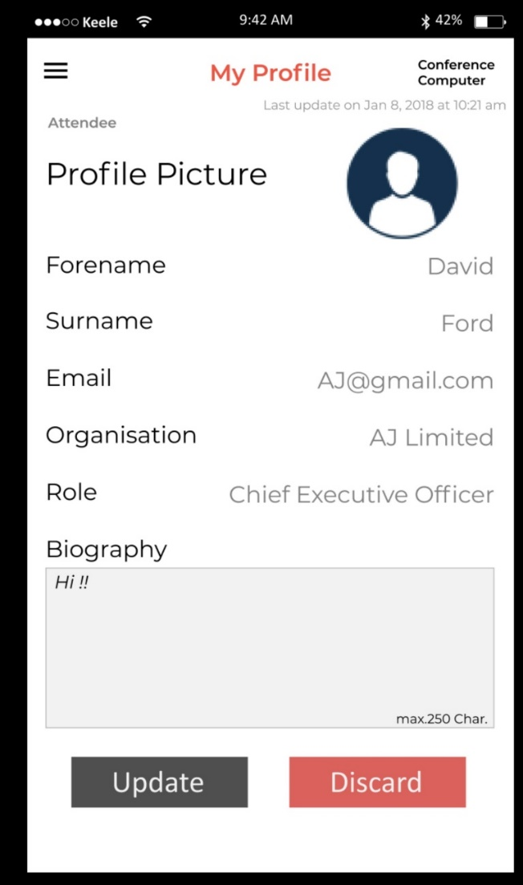**USER PROFILE PAGE**

UPDATES POST MEETING:

* Back button added

The profile page provides a clean way of updating what other conference attendees will see.

The profile picture is a basic placeholder but users can click it to use an image on the host device.

The form then contains the standard profile details such as name, organisation and email. By providing a section for biography, each user can tailor make their profile for each conference being attended.

All updates will be synced once the application is able to connect to the server which is indicated through a persistent updater text at the top of the Profile page.

If there have been any field changes by the user, pressing update will save these changes and take the user back to the homepage.

All fields can be clicked on & changed (saved information will show as placeholder so the user never see’s empty unless manually cleared.)

Clicking “discard” will just take the user back to their homepage with no changes saved.